


MINUTES
For the Ordinary Council Meeting
Held on the 31st January 2025

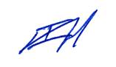
Ian Holland
CHIEF EXECUTIVE OFFICER
31st January 2025

Disclaimer:
The Shire of Yalgoo gives notice to members of the public that any decisions made at the meeting, can be revoked, pursuant to the Local Government Act 1995. Therefore members of the public should not rely on any decisions until formal notification in writing by Council has been received. Any plans or documents in agendas and minutes may be subject to copyright. The express permission of the copyright owner must be obtained before copying any copyright material.
Contents
1 DECLARATION OF OPENING 4
2 ATTENDANCE/APOLOGIES/LEAVE OF ABSENCE 4
3 DISCLOSURE OF INTERESTS 4
4 PUBLIC QUESTION TIME 5
5 PETITIONS/DEPUTATIONS/PRESENTATIONS/SUBMISSIONS 5
6 NOTICE OF MATTERS TO BE DISCUSSED BEHIND CLOSED DOORS 5
7 APPLICATIONS FOR LEAVE OF ABSENCE 5
8 ANNOUNCEMENTS CONCERNING MEETINGS ATTENDED 5
9 CONFIRMATION OF MINUTES 5
9.1 Minutes of the Ordinary Council Meeting – 20th December 2024 5
10 MINUTES OF COMMITTEE MEETINGS 6
11 TECHNICAL REPORTS 6
11.1 CAPITAL PROGRESS REPORT 6
11.2 TECHNICAL SERVICES REPORT AS OF 22nd January 2025 9
12 DEVELOPMENT, PLANNING AND ENVIRONMENTAL HEALTH REPORTS 12
13 FINANCIAL REPORTS 12
13.1 LIST OF ACCOUNTS 12
13.2 INVESTMENT REPORT 20
13.3 MONTHLY FINANCIAL STATEMENTS AS AT 31 DECEMBER 2024 22
14 ADMINISTRATION REPORTS 24
14.1 General Report 24
14.2 Sale of CAT Prime Mover 26
14.3 Local Government Elections 2025 27
14.4 Removal of Grid on Yalgoo-Ninghan Road 28
14.5 Party to Native Title Application 30
14.6 New Policy - Agenda Briefings 32
14.7 New Policy – Affixing of Common Seal 33
14.8 Policy – Recording of Council Meetings 35
14.9 New Policy – Related Party Disclosures 37
14.10 Policy Manual V6 Full Review 39
Items 14.11 to 14.14 were presented en bloc 42
14.11 Sundry Debtor #20062 – Write Off 42
14.12 Sundry Debtor #20072 – Write Off 43
14.13 Sundry Debtor #20112 – Write Off 44
14.14 Sundry Debtor #20132 – Write Off 45
15 NOTICE OF MOTIONS 46
16 URGENT BUSINESS 46
17 MATTERS FOR WHICH THE MEETING MAY BE CLOSED TO THE PUBLIC 46
17.1 Confidential Item – DFES EPAR 46
18 NEXT MEETING 47
19 MEETING CLOSURE 47

1 DECLARATION OF OPENING
The Shire President welcomed those in attendance and declared the meeting open at 11.49am.

2 ATTENDANCE/APOLOGIES/LEAVE OF ABSENCE
In accordance with section14 of the Local Government (Administration) Regulations 1996 “Meetings held by electronic means in public health emergency or state of emergency (Act s. 5.25(1)(ba))”, the President to declare that this Meeting may take place via instantaneous communication. All Councillors and staff are to be available either via telephone (teleconference) or in person.

President Cr Raul Valenzuela
Deputy President Cr Gail Trenfield - telephonic
Councilors Cr Stanley Willock
Cr Tamisha Hodder
Cr Kieran Payne
Cr Angus Nichols

Chief Executive Officer Ian Holland
Acting DCEO Karren MacClure
Executive Assistant Diane Hodder

APOLOGIES NIL

LEAVE OF ABSENCE NIL

3 DISCLOSURE OF INTERESTS
Councilors and Officers are reminded of the requirements of s5.65 of the Local Government Act 1995, to verbally disclose any interest during the meeting before the matter is discussed or to provide in writing the nature of the interest to the CEO before the meeting.
NIL

4 PUBLIC QUESTION TIME
REPONSES TO QUESTIONS TAKEN ON NOTICE
NIL

QUESTIONS TAKEN WITHOUT NOTICE
NIL

5 PETITIONS/DEPUTATIONS/PRESENTATIONS/SUBMISSIONS
Citizenship Ceremony

6 NOTICE OF MATTERS TO BE DISCUSSED BEHIND CLOSED DOORS
17.1 – DFES EPAR Application

7 APPLICATIONS FOR LEAVE OF ABSENCE
NIL

8 ANNOUNCEMENTS CONCERNING MEETINGS ATTENDED

Date | Location | Meeting | Attendance
24/01/2025  30/01/2025 | Geraldton  Mount Magnet | RFDS Political  Councillor Training – LG Financials | Cr Valenzuela, CEO Ian Holland  Cr Valenzuela, Cr Nichols, Cr Willock

9 CONFIRMATION OF MINUTES

9.1 Minutes of the Ordinary Council Meeting – 20th December 2024

RECOMMENDATION
That the minutes of the Council Meeting held on the 20th December 2024 as attached be confirmed as a true and correct record.
COUNCIL RESOLUTION – C2025-01-01
Moved: Cr Stanley Willock Seconded: Cr Kieran Payne
That the minutes of the Council Meeting held on the 20th December 2024 as attached be confirmed as a true and correct record.
CARRIED: 6/0
Motion Carried unopposed by: Cr Valenzuela, Cr Trenfield, Cr Hodder, Cr Payne, Cr Nichols & Cr Willock.

10 MINUTES OF COMMITTEE MEETINGS
NIL

11 TECHNICAL REPORTS

11.1 CAPITAL PROGRESS REPORT
Applicant: Shire of Yalgoo
Date: 10 January 2025
Reporting Officer: Charles Brown/Karren MacClure
Disclosure of Interest: NIL
Attachments: Capital Expenditure Report

SUMMARY
To receive the Progress Report on the 2024/25 Capital Works Program to 31 December 2024.

BACKGROUND
The Shire in its 2024/2025 Annual Budget has allocated the sum of $6,185,999 for the acquisition of capital assets and the undertaking of infrastructure works.

COMMENT
The Capital Projects detailed in the attached report are projects incorporated in the 2024/2025 Annual Budget.

STATUTORY ENVIRONMENT
NIL

POLICY/FINANCIAL IMPLICATIONS
To deliver the Capital Works Program within budgeted allocations.

VOTING REQUIREMENT
Simple Majority

OFFICERS RECOMMENDATION
That Council receive the Progress Report on the Capital Works Program as at 31 December 2024.
COUNCIL RESOLUTION – C2025-01-02
Moved: Cr Angus Nichols Seconded: Cr Gail Trenfield
That Council receive the Progress Report on the Capital Works Program as at 31 December 2024.
CARRIED: 6/0
Motion Carried unopposed by: Cr Valenzuela, Cr Trenfield, Cr Hodder, Cr Payne, Cr Nichols & Cr Willock.

45%
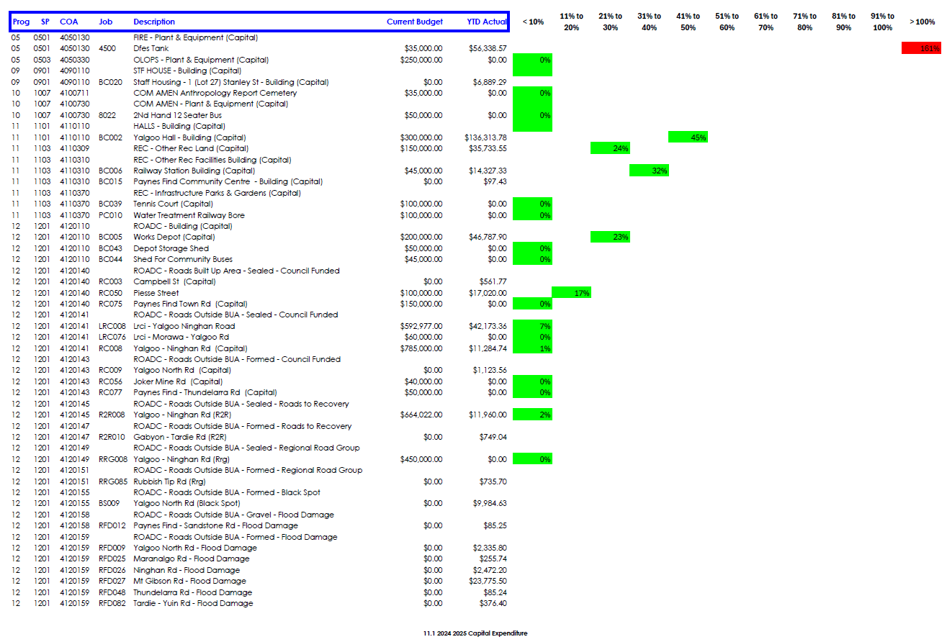

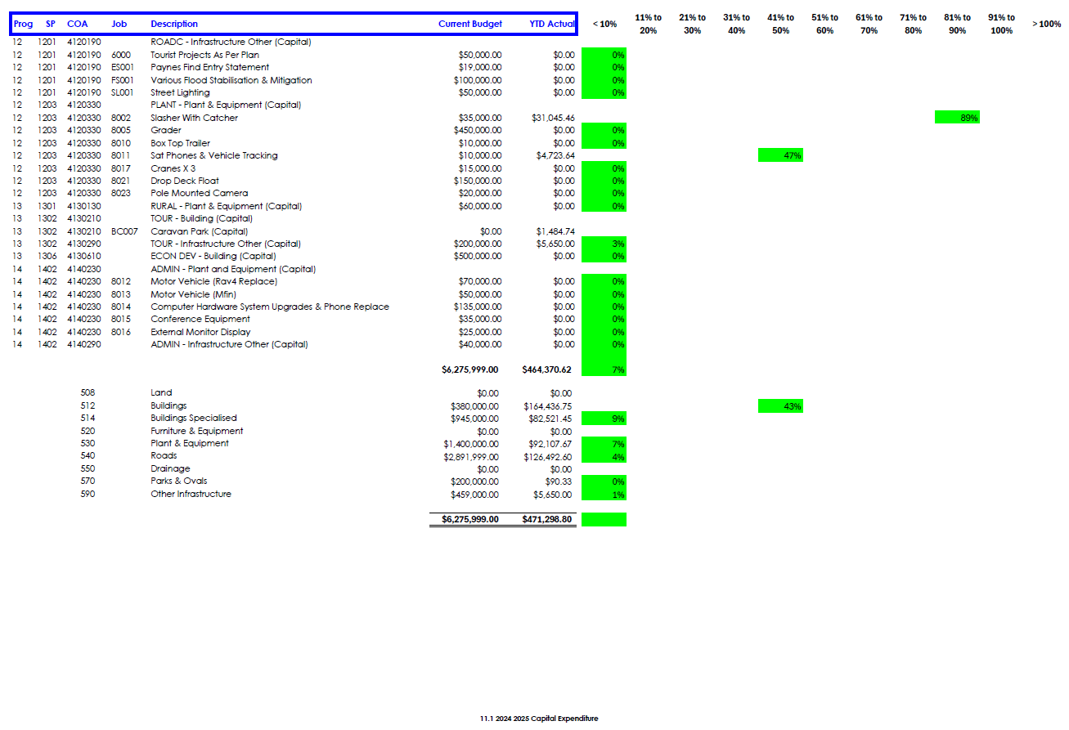

11.2 TECHNICAL SERVICES REPORT AS OF 22nd January 2025
Applicant: Shire of Yalgoo
Date: 22 January 2025
Reporting Officer: Darren Hawkins Acting Works Foreman
Disclosure of Interest: NIL
Attachments: NIL

SUMMARY
That Council receive the Technical Services Report as at the 22nd January 2025

COMMENT
Road Construction and Capital
- Yalgoo North Road – Replace old culvert.
Road Maintenance
- Maintenance Grading carried out on Dalgaranga Road.

Other Infrastructure
- Yalgoo/Morawa Road – Potholes Repairs.

Parks, Reserves and Properties
4.1 Art & Culture Centre
- General gardening maintenance carried out.

4.2 Community Town Hall
- Renovations still ongoing.

4.3 Community Town Oval
- General gardening maintenance carried out.
4.4 Community Park, Gibbons Street
- General gardening maintenance conducted on a weekly basis mowing, pruning and watering.
4.5 Community Park, Shamrock Street
- General gardening maintenance conducted on a weekly basis – Mowing, pruning & watering.
4.6 Water Park
- General gardening maintenance conducted.
4.7 Yalgoo Caravan Park
- Renovations being done on the center lawn.
4.8 Paynes Find Tip
- NIL
4.9 Railway Station
- General gardening maintenance conducted on a weekly basis – Mowing, pruning & watering.

4.10 Staff Housing
- NIL
4.11 Yalgoo Rubbish Tip
- Pushed over on a weekly basis.
4.12 Yalgoo & Paynes Find Airstrip
- Paynes Find Airstrip – checked and all good.
- Yalgoo Airstrip – checked and all good.
5. Staff
- NIL
6. Purchasing
- NIL
STATUTORY ENVIRONMENT
NIL

POLICY/FINANCIAL IMPLICATIONS
To deliver the Capital Works Program within budgeted allocations.

VOTING REQUIREMENT
Simple Majority

OFFICERS RECOMMENDATION
That Council receive the Technical Services Report as of 22nd January 2025.

COUNCIL RESOLUTION – C2025-01-03
Moved: Cr Stanley Willock Seconded: Cr Angus Nichols
That Council receive the Technical Services Report as of 22nd January 2025.
CARRIED: 6/0
Motion Carried unopposed by: Cr Valenzuela, Cr Trenfield, Cr Hodder, Cr Payne, Cr Nichols & Cr Willock.

12 DEVELOPMENT, PLANNING AND ENVIRONMENTAL HEALTH REPORTS
NIL

13 FINANCIAL REPORTS

13.1 LIST OF ACCOUNTS
Applicant: Shire of Yalgoo
Date: 10 January 2025
Reporting Officer: Charles Brown/ Karren MacClure
Disclosure of Interest: NIL
Attachments: Accounts Paid December 2024

SUMMARY
The attached list of accounts paid during the month of December 2024, under Delegated Authority, is provided for Council’s information and endorsement.

COMMENT
The Local Government Act 1995 and the Local Government (Financial Management) Regulations 1996 requires the Chief Executive Officer to present a list of accounts paid and/or payable to Council and to record those accounts in the minutes of the meeting.

STATUTORY ENVIRONMENT
Local Government Act 1995

6.10 Financial Management regulations
Regulations may provide for –
a. The security and banking of money received by a local government’ and
b. The keeping of financial records by a local government; and
c. The management by a local government of its assets, liabilities and revenue; and
d. The general management of, and the authorisation of payments out of –
I. The municipal fund; and
II. The trust fund, of a local government.

Local Government (Financial Management) Regulations 1996
13. Payments from municipal fund or trust fund by CEO, CEO’s duties as to etc.
1. If the local government has delegated to the CEO the exercise of its power to make payments from the municipal fund or the trust fund, a list of accounts paid by the CEO is to be prepared each month showing for each account paid since the last such list was prepared –
I. The payee’s name; and
II. The amount of the payment; and
III. The date of the payment; and
IV. Sufficient information to identify the transaction.
2. A list of accounts for approval to be paid is to be prepared each month showing –
a. For each account which requires council authorisation in that month –
I. The payee’s name; and
II. The amount of the payment; and
III. Sufficient information to identify the transaction; and
b. The date of the meeting of the council to which the list is to be presented.
3. A list prepared under sub regulation (1) or (2) is to be –
a. Presented to the council at the next ordinary meeting of the council after the list is prepared; and
b. Recorded in the minutes of that meeting.

13A. Payments by employees via purchasing cards
(1) If a local government has authorised an employee to use a credit, debit or other purchasing card, a list of payments made using the card must be prepared each month showing the following for each payment made since the last such list was prepared —
(a) the payee’s name;
(b) the amount of the payment;
(c) the date of the payment;
(d) sufficient information to identify the payment.
(2) A list prepared under sub regulation (1) must be —
(a) presented to the council at the next ordinary meeting of the council after the list is prepared; and
(b) recorded in the minutes of that meeting.

POLICY/FINANCIAL IMPLICATIONS
NIL

VOTING REQUIREMENT
Simple Majority

OFFICERS RECOMMENDATION
That Council receive the schedule of accounts paid during December 2024 as listed covering EFT’s directly debited payments, Credit Card Payments and wages as numbered and totalling $1,142,154.78 from the Shire of Yalgoo’s Municipal Bank Accounts.
COUNCIL RESOLUTION – C2025-01-04
Moved: Cr Stanley Willock Seconded: Cr Angus Nichols
That Council receive the schedule of accounts paid during December 2024 as listed covering EFT’s directly debited payments, Credit Card Payments and wages as numbered and totalling $1,142,154.78 from the Shire of Yalgoo’s Municipal Bank Accounts.
CARRIED: 6/0
Motion Carried unopposed by: Cr Valenzuela, Cr Trenfield, Cr Hodder, Cr Payne, Cr Nichols & Cr Willock.

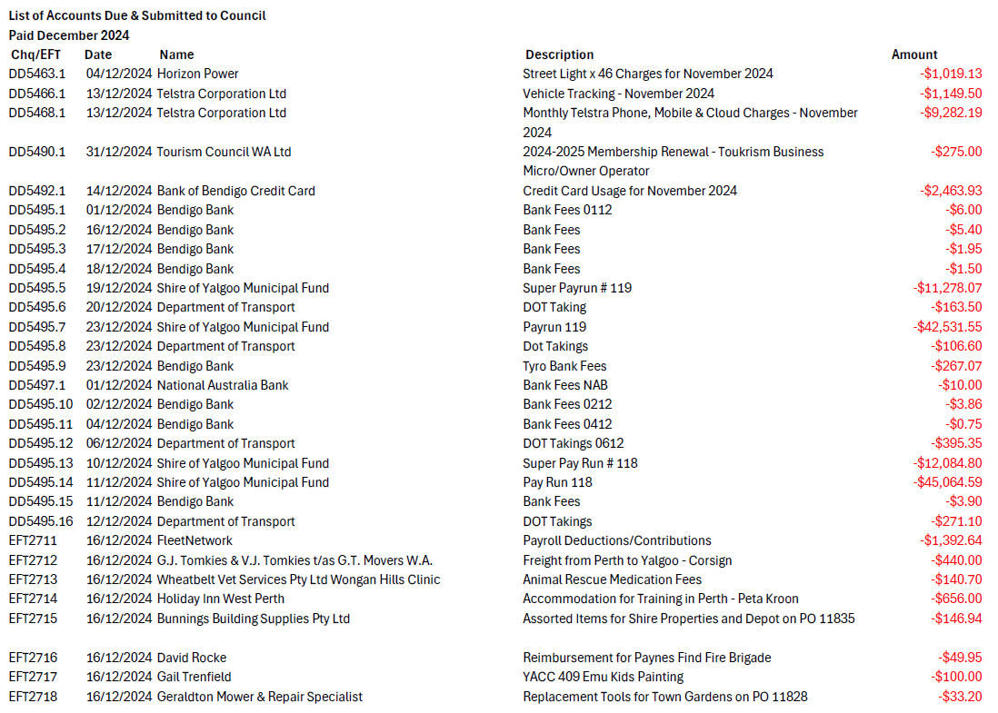
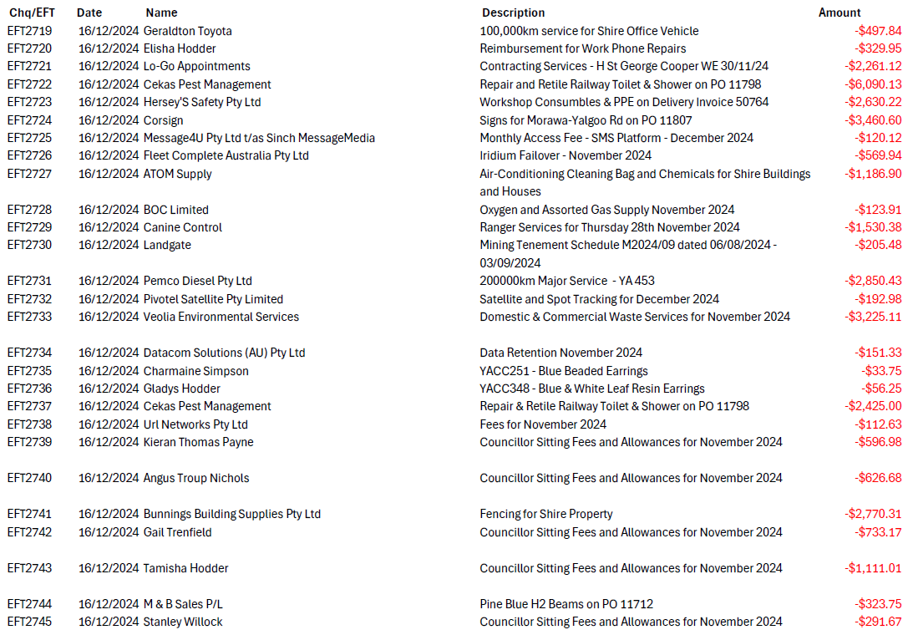
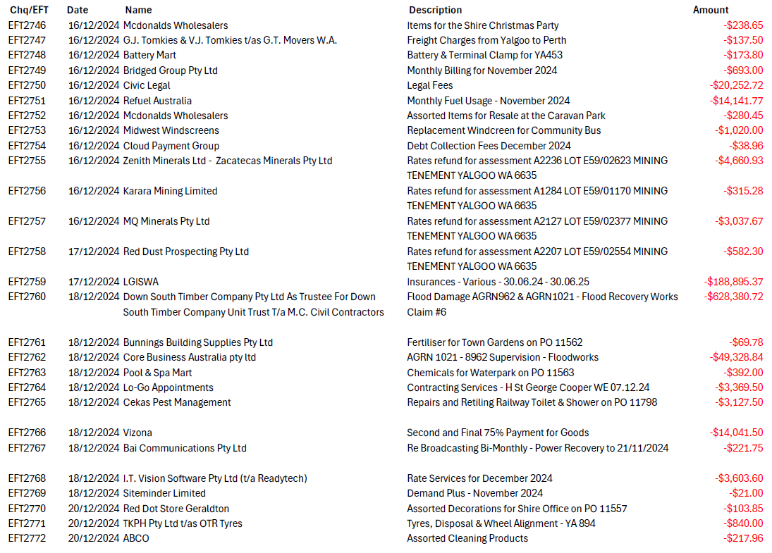
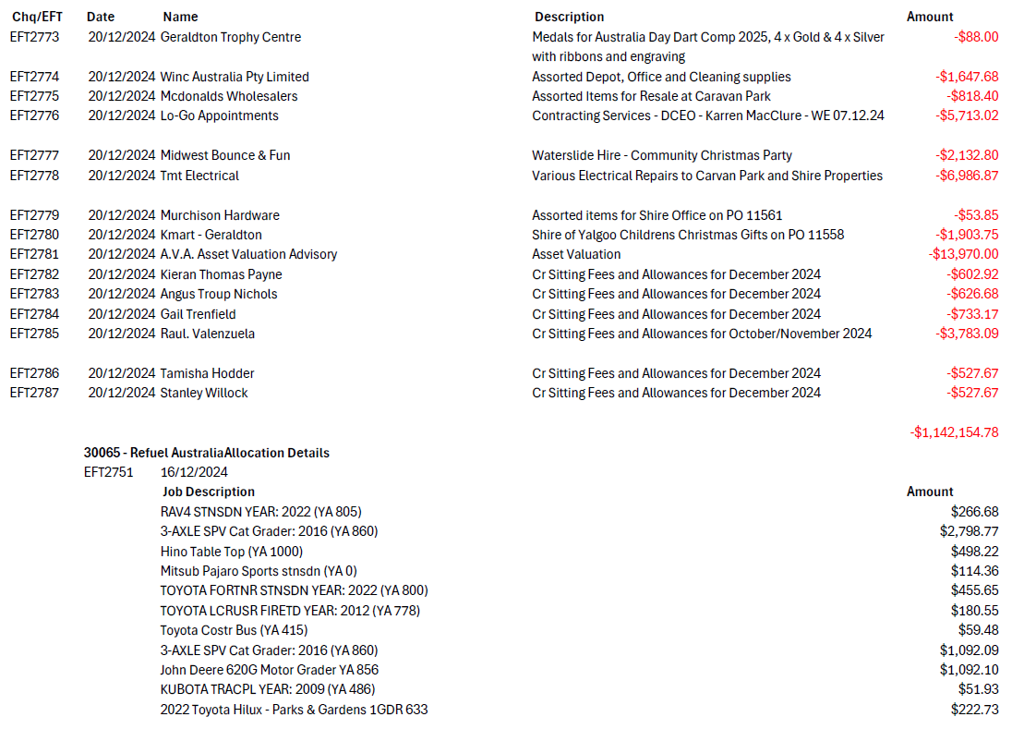
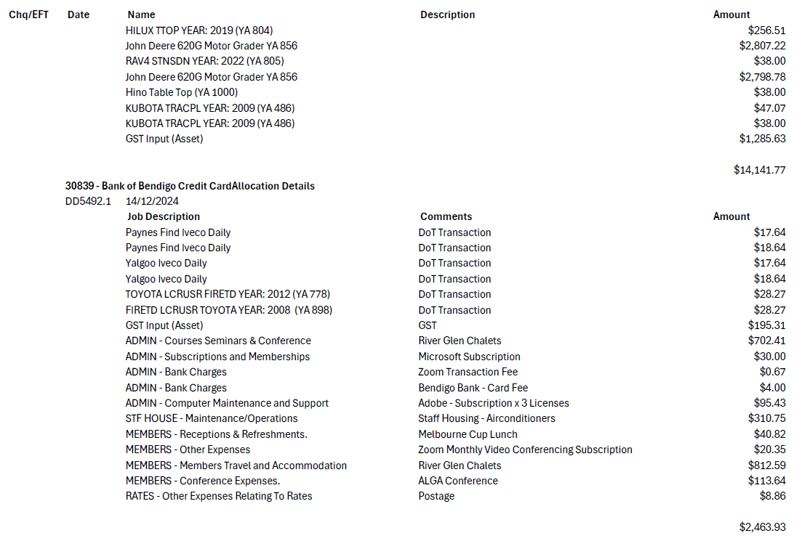

13.2 INVESTMENT REPORT
Applicant: Shire of Yalgoo
Date: 10 January 2025
Reporting Officer: Charles Brown / Karren MacClure
Disclosure of Interest: NIL
Attachments: Investment Register

SUMMARY
That Council receive the investment report as at 31 December 2024.
COMMENT
Money held in the Municipal Fund of the Shire of Yalgoo that is not required for the time being may be invested under the Trustee Act 1962 Part III.

STATUTORY ENVIRONMENT
Local Government Act 1995.
6.14 Power To Invest.

Local Government (Financial Management) Regulations 1996
19 Investments, control procedures for
19C Investment of money, restrictions on (Act s6.14(2)(a)

Shire Delegated Authority

POLICY/FINANCIAL IMPLICATIONS

VOTING REQUIREMENT
Simple Majority

OFFICERS RECOMMENDATION
That Council Receive the Investment Report as at 31 December 2024.
COUNCIL RESOLUTION – C2025-01-05
Moved: Cr Stanley Willock Seconded: Cr Gail Trenfield
That Council Receive the Investment Report as at 31 December 2024.
CARRIED: 6/0
Motion Carried unopposed by: Cr Valenzuela, Cr Trenfield, Cr Hodder, Cr Payne, Cr Nichols & Cr Willock.

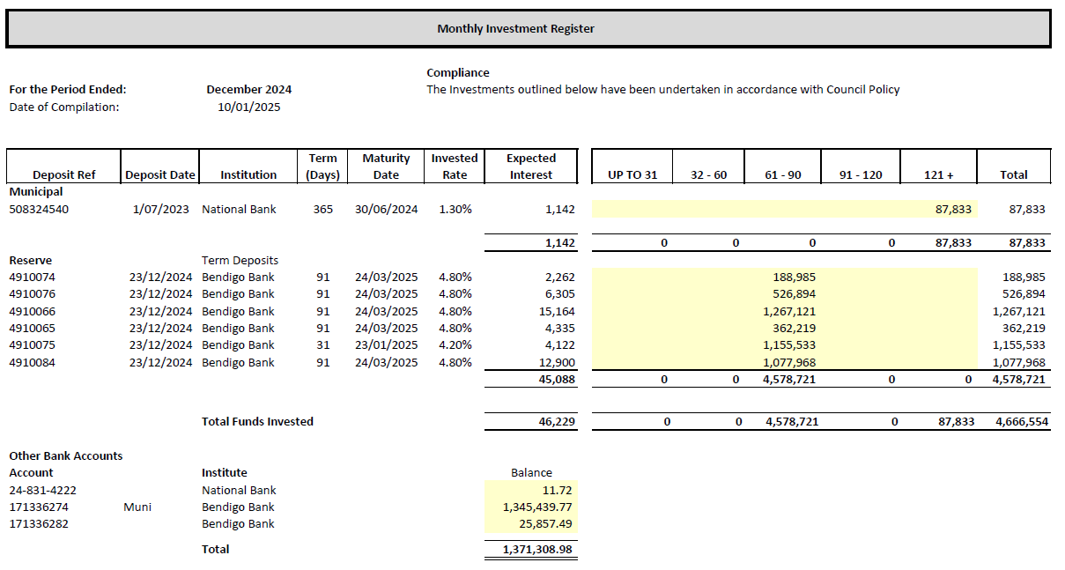

13.3 MONTHLY FINANCIAL STATEMENTS AS AT 31 DECEMBER 2024
Applicant: Shire of Yalgoo
Date: 10 January 2025
Reporting Officer: Charles Brown / Karren MacClure
Disclosure of Interest: NIL
Attachments: Page: 1-20 Statement of Financial Activity
Page: 21-38 Detailed Schedules
Page: 39-41 Variances at Sub Program Level
Page: 42 Rates Levied

SUMMARY
The Statement of Financial Activity report for the month ended 31 December 2024 is presented to council in accordance with Regulation 34 of the Local Government (Financial Management) regulations 1996.
COMMENT

Income and Expenditure Variance Operating.
As at 31 December 2024, year to date revenue from operating activities is up by 3.2% against budget, with expenditure from operating activities down 21.51% against budget.
Further explanation of Variances at Sub Program Level can be seen in the attached and the detailed look at individual COA or Job numbers can also be seen.
STATUTORY ENVIRONMENT
Local Government Act 1995 - Section 6.4
Local Government (Financial Management) Regulations 1996 - Regulation 34

POLICY/FINANCIAL IMPLICATIONS
The adoption of the Statements of Financial Activity is retrospective. Accordingly, the financial implications associated with adopting this are nil.

VOTING REQUIREMENT
Simple Majority

RISK IMPLICATIONS
The Financial Activity report is presented monthly and provides a retrospective picture of the activities at the shire. Contained within the report is information pertaining to the financial cost and delivery of strategic initiatives and key projects.
To mitigate the risk of budget over-runs or non-delivery of projects, the Chief Executive Officer (CEO) has implemented internal control measures such as regular Council and Management reporting and a quarterly process to monitor financial performance against budget estimates.
Materiality reporting thresholds have been established by council of $10,000 for budget operating and capital items to alert management prior to there being irreversible impacts.
It should be noted that there is an inherent level of risk of misrepresentation of the financials through either human error or potential fraud.
The establishment of control measures through a series of efficient systems, policies and procedures, which fall under the control of the CEO as laid out in the Local Government (Financial Management) Regulations 1996 regulation 5, seek to mitigate the possibility of this occurring.
These controls are set in place to provide daily, weekly and monthly checks to ensure that the integrity of the data provided is reasonably assured.

OFFICERS RECOMMENDATION
That Council receive the Statement of Financial Activity for the period ended 31 December 2024 in accordance with Regulation 34 of the Local Government (Financial Management) Regulations 1996.
COUNCIL RESOLUTION – C2025-01-06
Moved: Cr Kieran Payne Seconded: Cr Angus Nichols
That Council receive the Statement of Financial Activity for the period ended 31 December 2024 in accordance with Regulation 34 of the Local Government (Financial Management) Regulations 1996.
CARRIED: 6/0
Motion Carried unopposed by: Cr Valenzuela, Cr Trenfield, Cr Hodder, Cr Payne, Cr Nichols & Cr Willock.

14 ADMINISTRATION REPORTS

14.1 General Report
Applicant: Shire of Yalgoo
Date: 26/01/2025
Reporting Officer: Ian Holland Chief Executive Officer
Disclosure of Interest: NIL
Attachments: NIL

SUMMARY
That Council consider the Chief Executive Officers general operation report.

COMMENT

Yalgoo Hotel Business Case
A valuation has been received for the Yalgoo Hotel and based on a financial assessment a business case will not be required. Pending the adoption of the budget review, a proposal to purchase the property will be presented along with operational models. Administration is developing an Expression of Interest which will require Council endorsement before publication.

Councillor Training
Finance for non-financial people – LG Professionals (February)
Bookings will be made for two nights in Perth for Councillors who are able to attend this Course.

A Digital Access and Inclusion conference is being hosted by Wet Tech Assemblage and the City of Stirling on Thursday the 20th of February 2025. The conference is supported by WALGA and interested Councillors are encouraged to attend.

Consultation on regulations for CEO KPIs and Public Registers
Submissions have been invited by the Department of Local Government on proposed regulations to publish CEO performance indicators and other public information registers. An explanatory paper and the draft regulations are available on the DLGSC website, to assist in preparing submissions. Administration has contacted the Hon Sabine Winton Minister for Prevention of Family and Domestic Violence requesting consideration of an exemption for residential properties. A number of questions have also been submitted to the Department in the form of a submission.

Objection to Lease over Jokers Tunnel - FIJV
Lawyers for FIJV have asked the Shire to withdraw its objection against Mining Lease M59/780. This correspondence is available to Councillors.

Paynes Find Bushfires
Multiple fires occurred in Paynes Find over the Christmas break. Tremendous support was received from DFES Regional Office over this period.

External CEO Movements December
24th January - RFDS political announcement Geraldton
STATUTORY ENVIRONMENT
Local Government Act 1995

POLICY/FINANCIAL IMPLCATIONS
NIL

VOTING REQUIREMENT
Simple Majority

OFFICERS RECOMMENDATION
That Council receive the Chief Executive Officers General Report.
COUNCIL RESOLUTION – C2025-01-07
Moved: Cr Stanley Willock Seconded: Cr Gail Trenfield
That Council receive the Chief Executive Officers General Report.
CARRIED: 6/0
Motion Carried unopposed by: Cr Valenzuela, Cr Trenfield, Cr Hodder, Cr Payne, Cr Nichols & Cr Willock.

14.2 Sale of CAT Prime Mover
Applicant: Shire of Yalgoo
Date: 20/01/2025
Reporting Officer: Chief Executive Officer Ian Holland
Disclosure of Interest: NIL
Attachments: NIL

SUMMARY
That Council consider an auction amount for the CAT Prime Mover

COMMENT
Cooling of the market has resulted in multiple auctions returning sub-par results. A final offer of $50,000 has been received for the outgoing Prime Mover which is short of the $70,000 reserve.

The vehicle has been through 4 auctions and it is unlikely that the market will return to the initial high values received last year due with the resumed importation of new vehicles.

It is suggested that Council accept the $50,000 offer received at public auction.

POLICY/FINANCIAL IMPLCATIONS
NIL

VOTING REQUIREMENT
Simple Majority

OFFICERS RECOMMENDATION
That Council accept the sale of the CAT Primer Mover for $50,000 being the highest bid at public auction.
COUNCIL RESOLUTION – C2025-01-8
Moved: Cr Angus Nichols Seconded: Cr Tamisha Hodder
That Council accept the sale of the CAT Prime Mover for $50,000 being the highest bid at public auction.
CARRIED: 6/0
Motion Carried unopposed by: Cr Valenzuela, Cr Trenfield, Cr Hodder, Cr Payne, Cr Nichols & Cr Willock.

14.3 Local Government Elections 2025
Applicant: Shire of Yalgoo
Date: 20/01/2025
Reporting Officer: Chief Executive Officer Ian Holland
Disclosure of Interest: NIL
Attachments: Page:1-3 Estimate
Election Process

SUMMARY
That Council consider engaging the Electoral Commission to conduct the 2025 Ordinary Election for the Shire of Yalgoo.

COMMENT
As in previous years a cost estimate has been received from the Western Australian Electoral Commission (WAEC). An estimate of $10,000 (ex GST) has been received which is the same as the 2024 extraordinary election.

At this stage a local government is required to confirm the cost estimate and advise the WAEC in writing of the intention to engage them to manage an election. Further correspondence will then be received to officially appoint the Electoral Commissioner.

POLICY/FINANCIAL IMPLCATIONS
Inclusion into the 2025/26 Annual Budget.

VOTING REQUIREMENT
Simple Majority

OFFICERS RECOMMENDATION
That Council confirms the cost estimate for the Western Australian Electoral Commission to conduct the 2025 Shire of Yalgoo Ordinary Election.
COUNCIL RESOLUTION – C2025-01-09
Moved: Cr Stanley Willock Seconded: Cr Tamisha Hodder
That Council confirms the cost estimate for the Western Australian Electoral Commission to conduct the 2025 Shire of Yalgoo Ordinary Election.
CARRIED: 6/0
Motion Carried unopposed by: Cr Valenzuela, Cr Trenfield, Cr Hodder, Cr Payne, Cr Nichols & Cr Willock.

14.4 Removal of Grid on Yalgoo-Ninghan Road
Applicant: Shire of Yalgoo
Date: 20/01/2025
Reporting Officer: Chief Executive Officer Ian Holland
Disclosure of Interest: NIL
Attachments: NIL

SUMMARY
That Council approves the removal of a stock grid on Yalgoo-Ninghan Road.

COMMENT
Since late last year a grid on the boundary of Thundelarra and Warriedar Stations has required repairs multiple times. Heavy vehicles continue to rip loose and deform the railway steel on the grid.

This grid does not support a fence line and sits within a State Park that manages no stock. While the grid has historical significance there are numerous other functioning examples on the same road and within the local government area.

It is suggested that the grid be removed and replaced with a drainage culvert as part of general maintenance. Most steel sections will be kept as they may be usable in other locations. It is not suggested that any consultation be undertaken with the Department of Biodiversity, Conservation and Attractions.

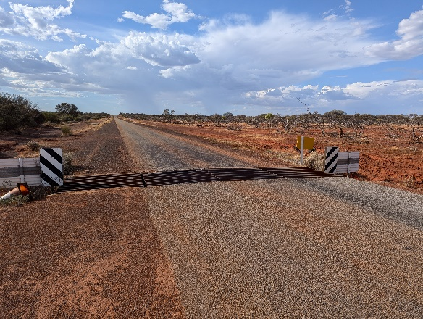
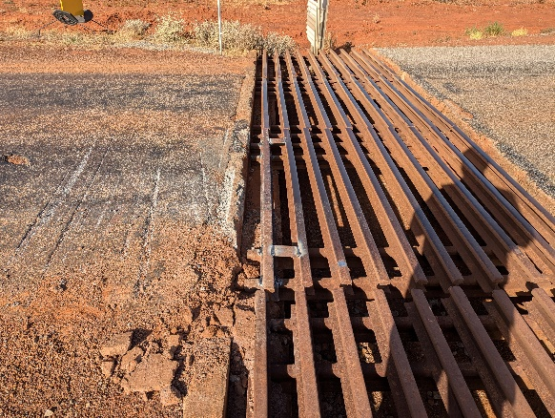

POLICY/FINANCIAL IMPLCATIONS
NIL

VOTING REQUIREMENT
Simple Majority

OFFICERS RECOMMENDATION
That Council approve the removal of a stock grid at SLK 61.73 on the Yalgoo-Ninghan Road
COUNCIL RESOLUTION – C2025-01-10
Moved: Cr Stanley Willock Seconded: Cr Kieran Payne
That Council approve the removal of a stock grid at SLK 61.73 on the Yalgoo Ninghan Road.
CARRIED: 6/0
Motion Carried unopposed by: Cr Valenzuela, Cr Trenfield, Cr Hodder, Cr Payne, Cr Nichols & Cr Willock.

14.5 Party to Native Title Application
Applicant: Shire of Yalgoo
Date: 20/01/2025
Reporting Officer: Chief Executive Officer Ian Holland
Disclosure of Interest: NIL
Attachments: Page: 5-7 Notification of Application WAD258/2024

SUMMARY
That Council considers a Native Title application registered over part of the local government area.

COMMENT
The Native Title Registrar has accepted application WAD258/2024 for registration. A description of the area is provided in the attached notice.

Native Title claim proceedings normally involve the following stages: registration, connection material and determination (contested of by consent).

Land where native title has not been extinguished, potentially including land administered by local governments, will be directly impacted by the outcome of a native title claim, as any native title rights and interests deemed to exist will co-exist with any pre-existing interests. Administration is not aware of any current or past assets in the determination area.

It should be noted that as part of a determination of a native title claim local governments may also choose to negotiate Indigenous Land Use Agreements with the native title holders to address issues such as compensation and land use post determination.

Based on the location of the claim and legal fees for existing applications Administration does not propose submitting a Notice of Intention to become a Party. Administration will consult further with other involved local governments and further advice may be provided closer to the date required for filing being 12th May 2025.

POLICY/FINANCIAL IMPLCATIONS
NIL

VOTING REQUIREMENT
Simple Majority

OFFICERS RECOMMENDATION
That Council note application WAD258/2024 for Native Title within a portion of the Shire of Yalgoo.
COUNCIL RESOLUTION – C2025-01-11
Moved: Cr Angus Nichols Seconded: Cr Kieran Payne
That Council note application WAD258/2024 for Native Title within a portion of the Shire of Yalgoo.
CARRIED: 3/3
Motion Carried by: Cr Trenfield, Cr Payne, Cr Nichols.

Opposed by Cr Willock, Cr Hodder & Cr Valenzuela

14.6 New Policy - Agenda Briefings
Applicant: Shire of Yalgoo
Date: 20/01/2025
Reporting Officer: Chief Executive Officer Ian Holland
Disclosure of Interest: NIL
Attachments: Page: 8-9 Policy – Agenda Briefings

SUMMARY
That Council consider the following policy on Agenda Briefing Meetings and Forums.

COMMENT
It is important to note that Agenda Briefing Sessions are not occasions for debate and should be seen as fact-finding opportunities. All questions should go through the Chair and no free flowing discussion or debate between Councillors is permitted.

The attached new policy is provided for Council Consideration.

POLICY/FINANCIAL IMPLCATIONS
New Policy

VOTING REQUIREMENT
Simple Majority

OFFICERS RECOMMENDATION
That Council adopt the as presented Policy on Agenda Briefings.
COUNCIL RESOLUTION – C2025-01-12
Moved: Cr Stanley Willock Seconded: Cr Kieran Payne
That Council adopt the as presented Policy on Agenda Briefing.
CARRIED: 6/0
Motion Carried unopposed by: Cr Valenzuela, Cr Gail Trenfield, Cr Hodder, Cr Payne,
Cr Nichols & Cr Willock.

14.7 New Policy – Affixing of Common Seal
Applicant: Shire of Yalgoo
Date: 20/01/2025
Reporting Officer: Chief Executive Officer Ian Holland
Disclosure of Interest: NIL
Attachments: Page: 10 Policy – Affixing of Common Seal

SUMMARY
Council does not currently have a policy relating to the execution of documents and affixing of the Common Seal, a new policy has been developed and is presented to council for review/adoption.

COMMENT
The Shire of Yalgoo is required to comply with The Local Government Act 1995, sections 9.49A (execution of documents) and 9.49 (documents, how authenticated). These sections detail the requirements for documents to be duly executed by a local government including the use of Common Seal.

Under the Act, for a document to be considered duly executed, the document must be executed in one of the following ways:
- By affixing the Common Seal of the Shire in the presence of the Shire President and Chief Executive Officer [s9.49A(3) of the act]; or
- Without affixing the Common Seal, by the Chief Executive Officer, another employee or agent of the Shire who has been authorized by resolution of Council to sign documents on behalf of the Shire [s9.49A(4) of the Act].

There is currently no policy giving guidance to officers to ensure the consistent and correct execution of documents/agreements and use of the Common Seal.

POLICY/FINANCIAL IMPLICATIONS

The introduction of this new policy gives clear direction regarding the execution of documents and use of Shire of Yalgoo Common Seal.

The implications of officers not executing documents correctly could have detrimental legal and financial implications to the Shire.

VOTING REQUIREMENT
Simple Majority

OFFICERS RECOMMENDATION
That Council adopt the attached new policy EXECUTION OF DOCUMENTS AND AFFIXING OF COMMON SEAL, to be inserted into the current Policy Manual.
COUNCIL RESOLUTION – C2025-01-13
Moved: Cr Stanley Willock Seconded: Cr Angus Nichols
That Council adopt the new policy EXECUTION OF DOCUMENTS AND AFFIXING OF COMMON SEAL, to be inserted into the current Policy Manual.
CARRIED: 6/0
Motion Carried unopposed by: Cr Valenzuela, Cr Trenfield, Cr Hodder, Cr Payne, Cr Nichols & Cr Willock.

14.8 Policy – Recording of Council Meetings
Applicant: Shire of Yalgoo
Date: 17/01/2025
Reporting Officer: Chief Executive Officer Ian Holland
Disclosure of Interest: NIL
Attachments: Page: 12-18 Policy – Recording of Council Meetings
Explanatory Paper – Recording of Council Meetings

SUMMARY
That Council adopt the new Policy ‘Recording of Council Meetings’ in line with legislative changes requiring the recording of Council Meetings from the 1st January 2025.

COMMENT
Major reforms to the Local Government Act 1995 are being delivered through:
1st Tranche – Local Government Amendment Act 2023: and
2nd Tranche – Local Government Amendment Act 2024

These changes have differing start dates and officers are currently working through those effecting Shire of Yalgoo as a class 4 Local Government.

One change introduced through the 1st Tranche and taking effect from 1st January 2025 is the requirement to audio record council meetings and make those recordings publicly available.

The attached policy sets a framework for the Shire of Yalgoo to work within to ensure compliance and the attached explanatory paper gives further detail on the legislative requirements relating to this topic (available on the Department of Local Governments website).

Overview of changes:

- Commencement – 1st January 2025
- Audio recording of all Ordinary Council Meetings, Special Council Meetings and AGMs required:
- To be made available to the public on the website within 14 days (open proceedings)
- Audio recording of closed meetings will not be made available to the public, however the recordings are to be retained by the Local Government for 5 years.
- All recordings retained for a period of 5 years

POLICY/FINANCIAL IMPLICATIONS
NIL

VOTING REQUIREMENT
Simple Majority

OFFICERS RECOMMENDATION
That Council adopt the attached policy RECORDING OF COUNCIL MEETINGS, to be inserted into the Policy Manual.
COUNCIL RESOLUTION – C2025-01-14
Moved: Cr Kieran Payne Seconded: Cr Gail Trenfield
That Council adopt the attached policy RECORDING OF COUNCIL MEETINGS, to be inserted into the Policy Manual.
CARRIED: 5/1
Motion Carried by: Cr Valenzuela, Cr Trenfield, Cr Hodder, Cr Payne, Cr Nichols.

Motion Opposed by Cr Willock.

14.9 New Policy – Related Party Disclosures
Applicant: Shire of Yalgoo
Date: 20/01/2025
Reporting Officer: Deputy CEO K MacClure/CEO I Holland
Disclosure of Interest: NIL
Attachments: Page: 20-26 Policy – Related Party Disclosures

SUMMARY
In response to a significant audit finding whereby it was found that Council does not have a policy for Related Party Disclosures, we now present for Council’s consideration and adoption, a new Related Party Disclosures Policy.

COMMENT
The Local Government (Financial Management) Regulations 1996, require all local governments to comply with the Australian Accounting Standards (AAS).

One such Accounting Standard that we are required to adhere to is AASB124 Related Party Disclosures. The objective of AASB124 is to ensure that an entity’s financial statements contain disclosures necessary to draw attention to the possibility its financial position and profit and loss may have been affected by the existence of related parties and by transactions and outstanding balances with such parties. Disclosures including related party relationships, transactions and outstanding balances are to be recorded in the Shires Annual Financial Statements.

This new policy explains the application of AASB 124 Related Party Disclosures on the Shire of Yalgoo and outlines the requirement mechanisms to meet the disclosure requirements including who is required to make a Related Party Disclosure, what is required to be disclosed and the process to facilitate this.

Significant Audit Finding

A significant finding by the external auditors for the Financial Year 2019 (and carried forward for 2020 and 2021 audit findings) is that “There is no documented Related Party Policy”. The Audit recommendation was for the Shire to develop and implement a Related Party Policy. In response to this finding a policy has now been developed.

POLICY/FINANCIAL IMPLICATIONS
The objective of AASB124 is to ensure that an entity’s financial statements contain disclosures necessary to draw attention to the possibility its financial position and profit/loss may have been affected by the existence of related parties and by transactions and outstanding balances with such parties. Without a policy to guide these requirements there is a possibility of the Annual Financial Reports containing incorrect related party information.

VOTING REQUIREMENT
Simple Majority

OFFICERS RECOMMENDATION
That Council adopt the attached new policy RELATED PARTY DISCLOSURES, to be inserted into the current Policy Manual.
COUNCIL RESOLUTION – C2025-01-15
Moved: Cr Stanley Willock Seconded: Cr Kieran Payne
That Council adopt the attached new policy RELATED PARTY DISCLOSURES, to be inserted into the current Policy Manual.
CARRIED: 6/0
Motion Carried unopposed by: Cr Valenzuela, Cr Trenfield, Cr Hodder, Cr Payne, Cr Nichols & Cr Willock.

14.10 Policy Manual V6 Full Review
Applicant: Shire of Yalgoo
Date: 20/01/2025
Reporting Officer: CEO I Holland
Disclosure of Interest: NIL
Attachments: Page: 27-241 Policy Manual V6

SUMMARY
The last full review of the Policy Manual adopted by council was in April 2020, as such a number of policies are overdue for review, a point that has been referenced in the auditors findings. We therefore present for Councils review and adoption the complete Organisational Policy Manual (version 6).

COMMENT
Section 2.7 (2)(b) of the Local Government Act 1995 prescribes that a primary function of the Council is determining the local government’s policies.

The last full review and adoption of the Policy Manual by council was April 2020 OCM. Changes to policies, and introduction of new policies have occurred since this date, and form part of the current Policy Manual attached. As many of the policies have not been formally reviewed/approved since 2020 it is timely for Council to undertake a general review of all current policies.

For ease of reference a summary of the changes proposed and included in the attached document are below. Further it should be noted that all new policies are being presented under separate agenda items for councils consideration and therefore not included in this review document.

Summary of Changes made to Policy Manual V6 attached:

Policy 1.6 Council Representation in External Organisations & Committees – table of delegates updated

Policy 1.10 Organisational Risk Management – audit finding 2022 – found that ISO 31000:2019 was incorrectly quoted in the policy. This has been updated to show ISO 3100: 2018 Risk Management Guidelines, which is the correct title. (audit issue resolved)

FREQUENCY OF POLICY REVIEW
Currently the policy Manual states that the policy manual should be reviewed at least once a year. This frequency is not achievable and not common practice in other councils, however as this is the current direction in the policy manual, this is how we are assessed by the auditors.
Changes have been made in the attached version to allow for each policy to be given a Review Frequency of up to 4 years. The sections changed are found on page 7 of the Manual titled New Policies and Review Frequency of Policies. In addition, each policy now has a Review Frequency inserted as clear guidance.

Current Wording (Policy Manual V5 2024)

New Wording (Policy Manual V6 2025):

POLICIES TO BE REVOKED
On review there are 2 Policies that are no longer relevant to be retained as policies and we are therefore requesting that they be revoked.
- 1.4 Council Chambers Usage (and Citizenship Dress Code)
- 3.7 Press Releases

Update on Audit Findings relating to Policies

Audit concerns regarding policies were raised as a Significant Audit Finding in 2019, 2020 & 2021 financial year audits. It is pleasing to report to council that all items raised have now been actioned by management. A summary of the findings is below for your reference:

Extract from Audit Report:

8. Out of date council policy manual
Status 2021
Finding:
Whilst completing our testing, we identified instances where the Council Policy Manual does not reflect current practices and is potentially out of date.
- Code of Conduct for Elected Members not in place (fixed - Policy 1.1)
- Investment Policy not located in Policy Manual (fixed – Policy 7.11)
- No Related Party Policy (fixed – policy in January 25 OCM Agenda for adoption)
- Policy 7.2 Purchasing missing Walga eQuotes & tender limit wrong (fixed)
- Numerous policies in the manual state either out of date or further work required (fixed – January25 OCM agenda - Full Policy Manual v6 for review/adoption)

POLICY/FINANCIAL IMPLICATIONS

Section 2.7 (2)(b) of the Local Government Act 1995 prescribes that a primary function of the Council is determining the local government’s policies.

VOTING REQUIREMENT
Simple Majority

OFFICERS RECOMMENDATION
That Council:
1. Adopt the reviewed Organisational Policy Manual V6 as attached.
2. Revoke Policy 1.4 Council Chambers Usage (and Citizenship Dress Code) and remove from the current Policy Manual; and
3. Revoke Policy 3.7 Press Releases and remove from the current Policy Manual.
COUNCIL RESOLUTION – C2025-01-16
Moved: Cr Kieran Payne Seconded: Cr Angus Nichols
That Council:
1. Adopt the reviewed Organisational Policy Manual V6 as attached.
2. Revoke Policy 1.4 Council Chambers Usage (and Citizenship Dress Code) and remove from the current Policy Manual; and
3. Revoke Policy 3.7 Press Releases and remove from the current Policy Manual.

CARRIED: 6/0
Motion Carried unopposed by: Cr Valenzuela, Cr Trenfield, Cr Hodder, Cr Payne, Cr Nichols & Cr Willock.

Items 14.11 to 14.14 were presented en bloc
Moved: Cr Kieran Payne Seconded: Cr Angus Nichols
CARRIED: 6/0

14.11 Sundry Debtor #20062 – Write Off
Applicant: Shire of Yalgoo
Date: 10 January 2024
Reporting Officer: H St. George Cooper – Corporate Services
Disclosure of Interest: NIL
Attachments: NIL

SUMMARY
That Council consider the write off for Sundry Debtor #20062 totalling $186.00

COMMENT
Two invoices were raised, one 26 May 2021 – accommodation at the Caravan Park, for $26.00, the other on 24 November 2021 – also for accommodation at the Caravan Park for $160.00, being for visiting personnel from State Government departments.
However, on investigation it has been found that the invoices were paid but not correctly allocated to the Sundry Debtors’ invoices.

STATUTORY ENVIRONMENT
Local Government Act 1995

POLICY / FINANCIAL IMPLICATIONS
This will not have a significant impact on projected 2024 – 2025 income.

VOTING REQUIREMENTS
Absolute Majority

OFFICERS RECOMMENDATION
That Council write off the outstanding debt of $186.00 for debtor #20062.
COUNCIL RESOLUTION – C2025-01-17
Moved: Cr Stanley Willock Seconded: Cr Angus Nichols
That Council write off the outstanding debt of $186.00 for debtor #20062.

CARRIED: 6/0

14.12 Sundry Debtor #20072 – Write Off
Applicant: Shire of Yalgoo
Date: 10 January 2024
Reporting Officer: H St. George Cooper – Corporate Services
Disclosure of Interest: NIL
Attachments: NIL

SUMMARY
That Council consider the write off for Sundry Debtor #20072 totalling $185.00

COMMENT
An invoice was raised on 30 June 2020 for a Food Business License Application.
However, on investigation it has been found that the invoice was paid but not correctly allocated to the Sundry Debtors’ invoices.

STATUTORY ENVIRONMENT
Local Government Act 1995

POLICY / FINANCIAL IMPLICATIONS
This will not have a significant impact on projected 2024 – 2025 income.

VOTING REQUIREMENTS
Absolute Majority

OFFICERS RECOMMENDATION
That Council write off the outstanding debt of $185.00 for debtor #20072.
COUNCIL RESOLUTION – C2025-01-17
Moved: Cr Stanley Willock Seconded: Cr Angus Nichols
That Council write off the outstanding debt of $185.00 for debtor #20072.

CARRIED: 6/0

14.13 Sundry Debtor #20112 – Write Off
Applicant: Shire of Yalgoo
Date: 10 January 2024
Reporting Officer: H St. George Cooper – Corporate Services
Disclosure of Interest: NIL
Attachments: NIL

SUMMARY
That Council consider the write off for Sundry Debtor #20112 totalling $160.00

COMMENT
An invoice was raised on 06 May 2021, for a payment received for accommodation of two units for 18 May 2021 at the Shire of Yalgoo’s Caravan Park.
However, on investigation it was an invoice raised instead of a receipt for a payment made in advance.

STATUTORY ENVIRONMENT
Local Government Act 1995

POLICY / FINANCIAL IMPLICATIONS
This will not have a significant impact on projected 2024 – 2025 income.

VOTING REQUIREMENTS
Absolute Majority

OFFICERS RECOMMENDATION
That Council write off the outstanding debt of $160 for debtor #20112.
COUNCIL RESOLUTION – C2025-01-17
Moved: Cr Stanley Willock Seconded: Cr Angus Nichols
That Council write off the outstanding debt of $160.00 for debtor #20112.

CARRIED: 6/0

14.14 Sundry Debtor #20132 – Write Off
Applicant: Shire of Yalgoo
Date: 10 January 2024
Reporting Officer: H St. George Cooper – Corporate Services
Disclosure of Interest: NIL
Attachments: NIL

SUMMARY
That Council consider the write off for Sundry Debtor #20132 totalling $185.00

COMMENT
An invoice was raised on 30 June 2020, for a Food Business License Application.
However, on investigation it has been found that the invoice was paid but not correctly allocated to the Sundry Debtors’ invoice.

STATUTORY ENVIRONMENT
Local Government Act 1995
POLICY / FINANCIAL IMPLICATIONS

This will not have a significant impact on projected 2024 – 2025 income.

VOTING REQUIREMENTS
Absolute Majority

OFFICERS RECOMMENDATION
That Council write off the outstanding debt of $185.00 for debtor #20132.
COUNCIL RESOLUTION – C2025-01-17
Moved: Cr Stanley Willock Seconded: Cr Angus Nichols
That Council write off the outstanding debt of $185.00 for debtor #20132.

CARRIED: 6/0

Motion Carried unopposed by: Cr Valenzuela, Cr Trenfield, Cr Hodder, Cr Payne, Cr Nichols & Cr Willock.

12.14pm Cr Nichols left the meeting.
12.15am Cr Nichols returned to the meeting.

15 NOTICE OF MOTIONS
NIL

16 URGENT BUSINESS
NIL

17 MATTERS FOR WHICH THE MEETING MAY BE CLOSED TO THE PUBLIC

COUNCIL RESOLUTION – C2025-01-18
Moved: Cr Stanley Willock Seconded: Cr Tamisha Hodder
That Council move behind closed doors to discuss the items in section 17 as they have been identified as relating to s5.23(2) Subsection/s (a).
CARRIED: 6/0
Motion Carried unopposed by: Cr Valenzuela, Cr Trenfield, Cr Hodder, Cr Payne, Cr Nichols & Cr Willock.

17.1 Confidential Item – DFES EPAR
Applicant: Shire of Yalgoo
Date: 28/01/2025
Reporting Officer: Ian Holland Chief Executive Officer
Disclosure of Interest: NIL
Attachments: Non approval of Cost Estimate for Essential Public Asset Reconstruction Works under the Disaster Recovery Funding Arrangements Western Australia (DRFAWA) for AGRN1021 – Flooding Midwest and Gascoyne (26 March – 3 April 2022).
Non approval of Cost Estimate for Essential Public Asset Reconstruction Works under the Disaster Recovery Funding Arrangements Western Australia (DRFAWA) for AGRN962 – Storm, Heavy Rain and Associated Flooding in the Mid-West and Southwest Land Division (1-5 March 2021).
Civic Legal – Advice in Review of Decision by Department of Fire and Emergency Services
AGRN962 & AGRN1021 Timeline
Additional DFES Correspondence
Letter from the Minister for Emergency Services
Draft Press Release

COUNCIL RESOLUTION – C2025-01-19
Moved: Cr Stanley Willock Seconded: Cr Angus Nichols
That Council:
1. Confidentially considers the legal advice provided by Civic Legal;
2. Support the development of a submission to the Parliamentary Commissioner for Administrative Investigations;
3. Considers budget cuts and the use of reserve funds in conjunction with the Shires Mid-Year Budget Review as the preferred method of cost recovery, over loan funds;
4. Provides the attached legal advice to other Local Governments seeking interest in cost sharing or a class action against Department of Fire and Emergency Services: and
5. Endorses a final press release and authorizes the Shire President and Chief Executive Officer to discuss the claims process and Council’s intentions publicly.

CARRIED: 5/1
Motion Carried by: Cr Valenzuela, Cr Hodder, Cr Payne, Cr Nichols & Cr Willock.
Motion Opposed By Cr Trenfield.
COUNCIL RESOLUTION – C2025-01-20
Moved Cr Angus Nichols Seconded: Cr Stanley Willock
That Council move out from behind closed doors.
CARRIED: 6/0
Motion Carried unopposed by: Cr Valenzuela, Cr Trenfield, Cr Hodder, Cr Payne, Cr Nichols & Cr Willock.

18 NEXT MEETING
The next Ordinary Meeting of Council is due to be held in the Council Chambers, Gibbons Street Yalgoo on Friday 28th February 2025 commencing at 10.30 am.

19 MEETING CLOSURE
There being no further business the Shire President declared the Ordinary meeting closed at 12.31 pm.
DECLARATION
These minutes were confirmed at the Ordinary Council Meeting held on the 7th March 2025.

Signed: ___________________________________________________

Person presiding at the meeting at which these minutes were confirmed.

